CUSTOM LTO LABEL ORDER

Date: |  | PO #:
Bill to: |  |  |  |  | Ship to:
Street: |  |  |  |  | Street:
City: |  |  |  |  | City:
State: |  | Zip: |  |  | State: |  | Zip:
Country: |  |  |  |  | Country:
Ship via: | Frt. pre-paid & add Collect
Frt. Carrier/Method:
Acct. No: |  |  | (Please indicate whether freight collect of 3rd party)

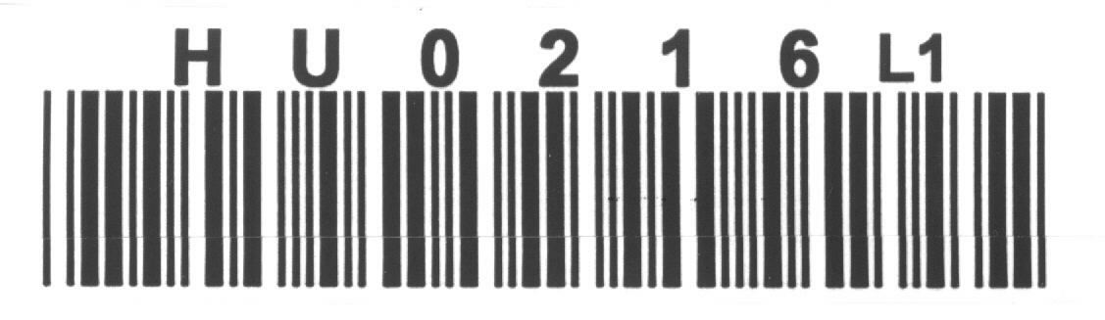 | WITH CHECK DIGIT
 | WITHOUT CHECK DIGIT
SSLTOI

734-0043-4 LTO6 Barcode Label with check character
734-0044-2 LTO6 Barcode Label without check character
734-0045-9 LTO7 Barcode Label with check character
734-0046-7 LTO7 Barcode Label without check character
734-0054-1 LTO8 Barcode Label with check character
734-0055-8 LTO8 Barcode Label without check character

QUANTITY:
SEQUENCE - 6 DIGITS STARTING WITH: |  |  |  | ( Numbering formats:  annnnn, aannnn or aaannn )
REMARKS:
E-mail to: orders@qualstar.com
For Qualstar Use Only
Qualstar SO # |  |  | Qualstar PO #

